Why this why now: Evaluating the potential for transformational changes in ecosystem condition and wildfire risk for TNC’s Midwest Division and NE Minnesota
Wildfires, drought, ice- and windstorm events, and other natural disturbances are foundational processes that shape the condition of ecosystems, and the services they provide to people. Anthropogenic drivers like introduced pests and pathogens, groundwater depletion, and fire suppression can disrupt natural processes, and reduce the resilience of forest ecosystems to disturbances. Further, we expect that climate change, especially temperature-related increases in evaporative demand (a key indicator of water loss rates from soils and vegetation), has the potential to rapidly amplify the effects of anthropogenic stressors, promoting drought stress in forest vegetation, and transformational increases in fire risk. While these risks to Midwest Division and NE Minnesota forests are pervasive and associated with many uncertainties, understanding the spatial patterns of past disturbances, current vegetation conditions, management and water use history, and site conditions can help us compare relative risks for catastrophic fires. Additional work to define and map focal social and ecological values, and indicators of management capacity, can later build from these risk layers to help TNC staff align risk with strategies.
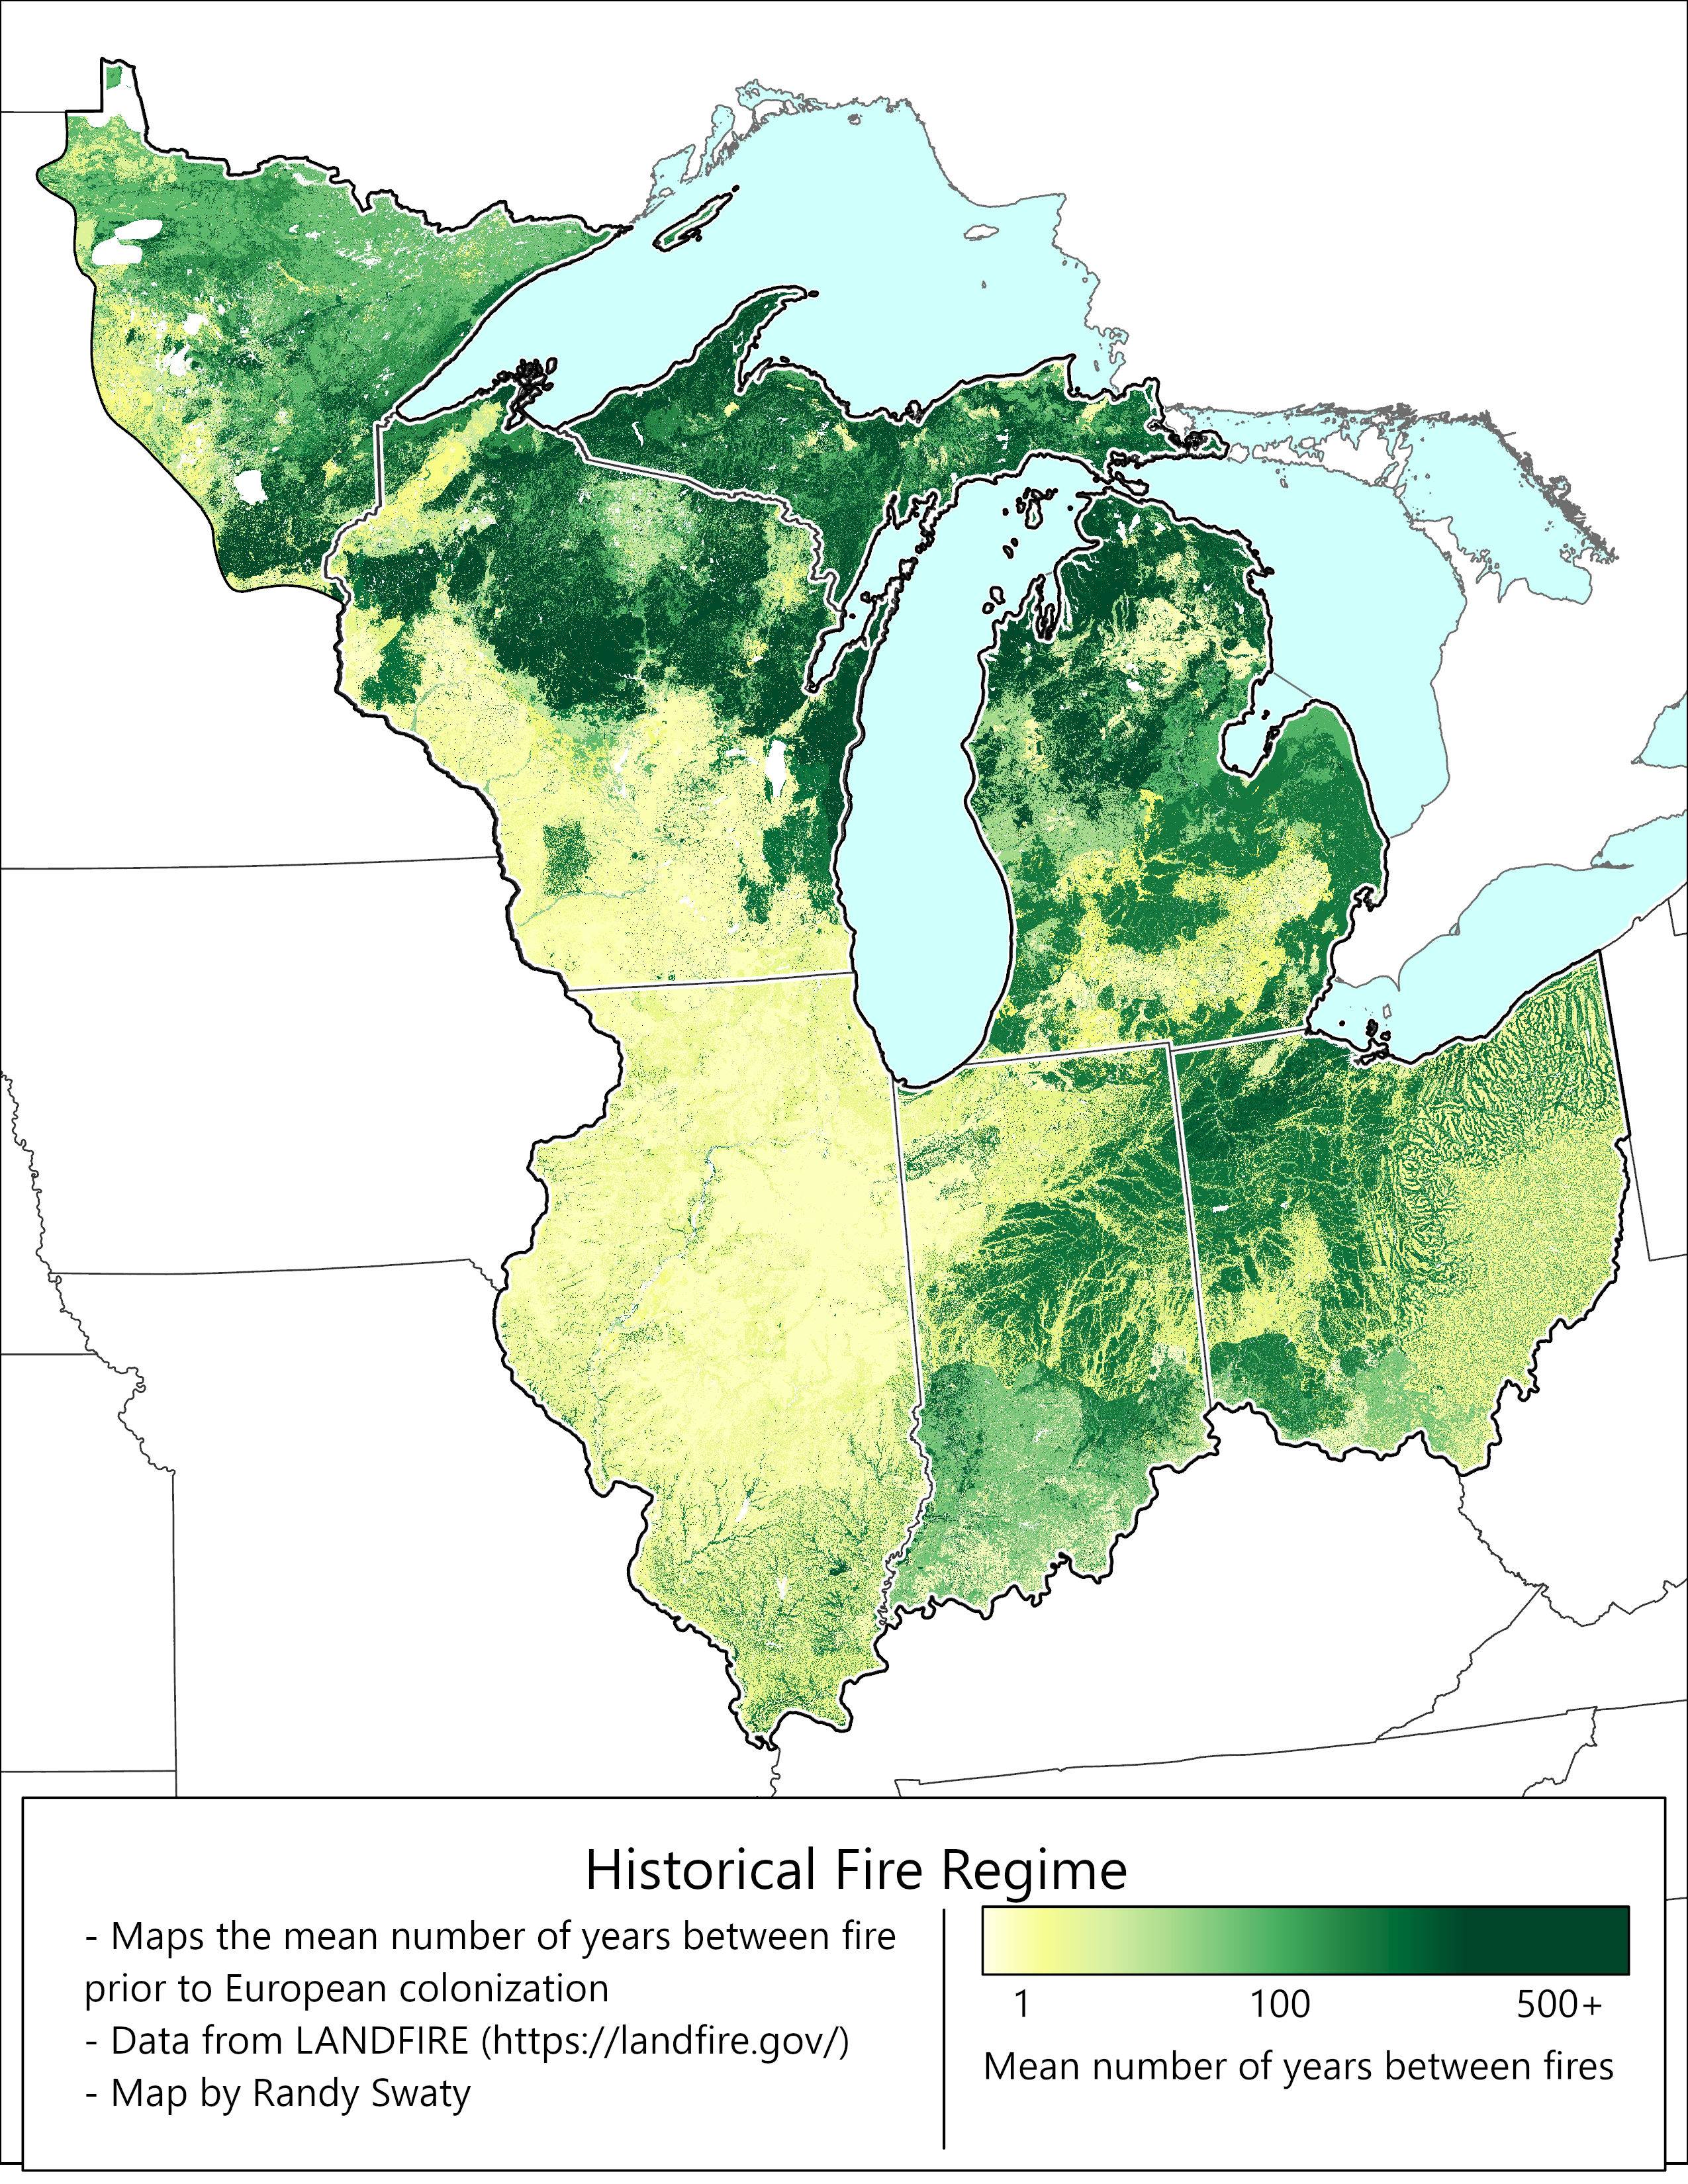
Figure 1. An estimated ~14M acres of land burned annually prior to European colonization, with highest frequency of fire in areas shown in yellows.

We will engage with key staff members to identify theories of change related to changing fire risks, and work with existing data sets to spatially integrate these risk factors with baseline fire risk datasets, such as historical fire regime (Figure 1). Through this work, we will lay the groundwork for collaborative, proactive strategy development. By considering historic data, current vegetation and climate conditions, and future projections, we will provide a rapid yet holistic assessment of risks that provides a foundation for driver-focused strategies. (e.g., addressing forest mesophication, increasing access to mills, etc.). We propose the following deliverables:
- A simple online dashboard (in the style of https://landfire-tnc.github.io/Assessments/) that contains: (a) selected maps and information on past, present and potential future wildfires, and (b) case studies that illustrate challenges and opportunities (see 3).
- Documentation of the evidence base for various drivers of increasing fire risk in this landscape identified through literature review and consultation with Midwest staff and regional experts.
- Future-looking maps and preliminary ideas on potential actions, co-developed with Midwest staff and based on expert opinion, literature review, and exploratory modeling.

